LUDDENHAM PUBLIC SCHOOL
STUDENT WELLBEING POLICY

Student wellbeing is fundamental to the achievement of Government priorities for the Public School System. In line with this, Luddenham Public School has a school discipline policy that has been developed in consultation with staff, students and school community members. This document should be read in conjunction with the NSW Department of Education and Training Student Welfare policy statement.

Core Purpose

Our core purpose at Luddenham Public School is to provide our students with a safe and nurturing learning environment in which they can connect, succeed and thrive. We aim to provide differentiated, stimulating and engaging learning experiences that cater for the individual needs of all learners. We strive to develop positive relationships with students and enable them to feel a sense of belonging to our school and wider community. We endeavour to provide an inclusive school community that empowers all students to succeed and develop into lifelong learners.

This policy aims to help our students develop:

- A sense of enjoyment and satisfaction from learning;
- An ability to communicate effectively;
- A coherent set of values to guide behaviour;
- A sense of personal and social responsibility for actions and decisions;
- A sense of personal dignity and worth;
- Self-reliance and resilience;
- A sense of cultural identity;
- A feeling of belonging to the wider community;
- A caring attitude towards others; and
- An ability to form satisfying and stable relationships.
The principal and school staff, using their professional judgment, are best placed to maintain discipline and provide safe, supportive and responsive learning environments. The department provides a policy framework and resources such as Legal Issues Bulletins, access to specialist advice, and professional learning to guide principals and their staff in exercising their professional judgment. In this context the NSW Government and the Department of Education will back the authority and judgment of principals and school staff at the local level.
Luddenham Public School staff will implement the policies and procedures of our student wellbeing policy by:

- Communicating the policy to students within the classroom and the playground; and
- Discussing the rights and responsibilities of students with them.

Introduction
At Luddenham Public School our Student Welfare Policy is supported by three school wide expectations or rules.

Our School Expectations are:
We are SAFE – ensure all members of our school community conduct themselves in a safe manner
We are RESPECTFUL – demonstrate kindness and fairness by treating staff, students and community members with respect at all times
We are RESPONSIBLE – strive to do your best and take responsibility for our learning and our behaviour both in and out of the classroom

Our school wide expectations provide:
- A small number of easy to remember expected student behaviours;
- Consistently implemented behavioural support;
- A shared understanding of expected behaviours by staff, students and community;
- Opportunities for students to take responsibility for their learning and the behavioural choices they make;
- A scaffold for the teaching and practicing of appropriate social skills and student behaviour; and
- Clear consequences for student behaviour;

These principles are basic to our expected student behaviour:
- All individuals are responsible for valuing others and treating them with respect;
- Students have the right to work in a safe environment where they are able to fully develop their talents and interests;
- Parents have a right to expect that their children will be able to learn in a safe environment in which care and responsibility are encouraged;
- Teachers have the right to expect that they will be able to teach in a mutually respectful, supportive and co-operative environment;
- Parents, teachers and students will share the responsibility in maintaining a positive teaching and learning environment;
- All stakeholders have an obligation to ensure that this policy is implemented in a fair and consistent manner.
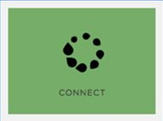 |  | 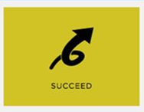
CONNECT  Our students will be actively connected to their learning, have positive and respectful relationships and experience a sense of belonging to their school and community |  | SUCCEED  Our students will be respected, valued, encouraged, supported and empowered to succeed. |  | THRIVE  Our students will grow and flourish, do well and prosper.
2.1 | School Anti-bullying Plan and Cyber Bullying Information Guide | 3.1 | Student Wellbeing and Discipline Code | 4.1 | The Wellbeing Framework for Schools
2.2 | School Uniform Policy | 3.2 | Protecting and Supporting Children and Young People Policy | 4.2 | Luddenham Public School Sunsmart Policy
2.3 | Student Representative Council Policy | 3.3 | Luddenham Public School PBL Matrix | 4.3 | Student Health - including health care plans, immunisation, administration of prescription medicine and Healthy School Canteen Strategy
2.4 | School Attendance Policy | 3.4 | Assisting Students with Learning Difficulties | 4.4 | Sport and Physical Activity Policy
2.5 | School Excursion Policy | 3.5 | Learning Assistance Team Policy | 4.5 | Road Safety and Drug education
 |  | 3.6 | Out-of-Home Care—(OOHC) Policy | 4.6 | Wellbeing education

Luddenham Public School PBL Matrix

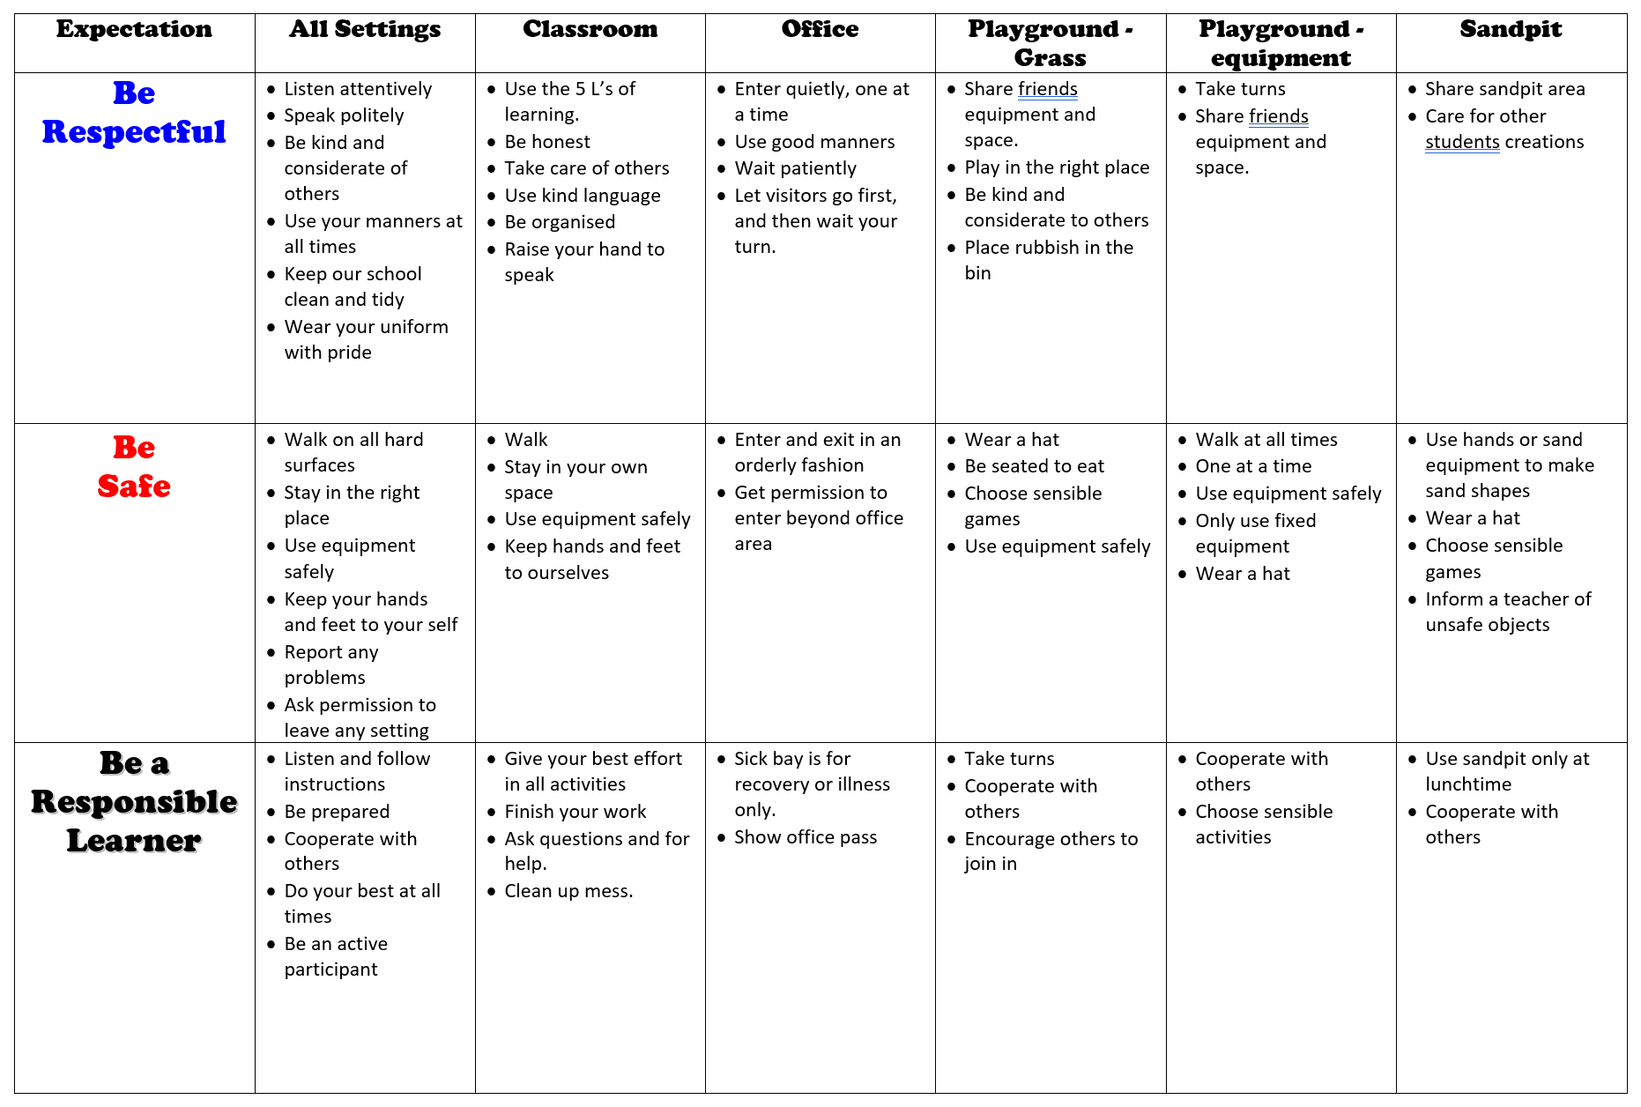
Luddenham Public School Behaviour Levels

At Luddenham Public School we believe all students have the right to learn in a safe, caring and challenging environment free from harm. We follow a level consequence system across the school when dealing with negative behaviours. Behaviours are organised into four levels – Green, White (monitoring ‘On Watch’), Yellow (‘Final Chance’) and Red - depending on the intent with which the behaviour occurs. The system is implemented consistently across all areas of the school and follows the procedure outlined below.

Level | Reason for being placed on this level | What happens on this level
Green | - Students placed on this level when they enrol at our school.  - Students obey the school rules and promote core value. | - Students may participate in all school activities.  - Student involved in PBL Program.
Monitoring  ‘On Watch’ | - Student is not adhering to school rules or core value.  - Student continually disobeys teacher instructions  - Student moved down the behaviour chart to Time Out In Other Classroom (which results in the student being sent to the Principal) | - Student is given a monitoring sheet/card.  - Duration determined by behaviour (determined by the Principal).  - Students who repeatedly demonstrate minor behaviours may be required to attend “Zones of Regulation” program  - Parent notification. (phone call – contact made by Principal)
Yellow  ‘Final Chance’ | - Student has repeatedly broken school rules or core values.  - Student has demonstrated unacceptable/major behaviour. (Please see Behaviour Management Flowchart for list. Behaviours could include: spitting, biting, racist remarks, derogatory remarks/behaviour etc).  - First instance of abusive behaviour | As for monitoring level and:  - Student placed on Yellow Level Monitoring Card  - Principal and classroom teacher discuss management strategies for the student’s behaviour.  - Parents/carers are notified by phone (Principal will make this call).  - Student attends Zones of Regulation program and is withdrawn from the playground for both breaks.  - Privileges are withdrawn from the student.  - Students progresses to monitoring level when ‘Yellow’ level is completed  - Principal to contact parents regarding the progress of the student
Red  (Specifics of this program are organised on an individual basis) | - All previously mentioned strategies have proven unsuccessful.  - Student continues to disobey school rules and ignore core values.  - Second instance of abusive behaviour.  - Student may be placed on this level on the recommendation of the Principal for extreme examples of major behaviours. | In-school suspension:  - Withdrawal from class and playground.  - Student provided with work and placed in a pre-arranged setting  - Interview/contact with parents/carers to be held before the child progresses to yellow level and returns to class.  - Warning to suspend letter will be issued  Suspension:  - In accordance with DoE Suspension and Expulsion of School Student Procedures  - Work set by class teacher is to be completed at home and brought to the resolution meeting.  - Student returns to school on ‘Yellow’ Level.  - Suspension Resolution meeting with School Counsellor and parents/carers to be held before the child returns to school.

Student name (K-2 monitoring chart)
- I will always behave safely.
- I will do my work respectfully.
- I will follow instructions responsibly.
 | Monday | Tuesday | Wednesday | Thursday | Friday
Morning
Middle
Afternoon

Student name (K-2 monitoring chart – if break required)
- I will always behave safely.
- I will do my work respectfully.
- I will follow instructions responsibly.
 | Monday | Tuesday | Wednesday | Thursday | Friday
Before School
Break 1
Break 2

YELLOW BEHAVIOUR CARD
The Yellow Behaviour Card allows students to reflect on their behaviour. The classroom teacher will tick each box that has been completed each day. The Yellow Behaviour Card will be sent home each day with the student. The behaviour card is to be signed by the student and the student’s parent/carer at the end of each day and returned to school to better monitor the student’s behaviour.
 | Behaviour | School Work | Signed
Day One | - Raised hand to speak  - Listened to other people speaking in class  - Was kind to others  - Kept hands and feet to self  - Used words to fix or resolve problems | - Followed teacher directions/instructions  - Paid attention  - Participated in class  - Completed all work  - Used materials correctly  - Worked well with others
Day Two | - Raised hand to speak  - Listened to other people speaking in class  - Was kind to others  - Kept hands and feet to self  - Used words to fix or resolve problems | - Followed teacher directions/instructions  - Paid attention  - Participated in class  - Completed all work  - Used materials correctly  - Worked well with others
Day Three | - Raised hand to speak  - Listened to other people speaking in class  - Was kind to others  - Kept hands and feet to self  - Used words to fix or resolve problems | - Followed teacher directions/instructions  - Paid attention  - Participated in class  - Completed all work  - Used materials correctly  - Worked well with others
Day Four | - Raised hand to speak  - Listened to other people speaking in class  - Was kind to others  - Kept hands and feet to self  - Used words to fix or resolve problems | - Followed teacher directions/instructions  - Paid attention  - Participated in class  - Completed all work  - Used materials correctly  - Worked well with others
Day Five | - Raised hand to speak  - Listened to other people speaking in class  - Was kind to others  - Kept hands and feet to self  - Used words to fix or resolve problems | - Followed teacher directions/instructions  - Paid attention  - Participated in class  - Completed all work  - Used materials correctly  - Worked well with others
Accumulative award system at Luddenham Public School
The aim of this system is to recognise the successes and achievements of students across their school life at Luddenham Public School. Students are recognised for following the school’s core values of being a safe, respectful and a responsible student. There is no timeframe for the collection of these rewards and it will be the student’s responsibility to submit awards.

The system starts with students receiving ‘Success Awards’ in class settings. The ‘Success Awards’ are tracked by the student and it is recommended that any awards remain in the student’s tote tray or otherwise remain at school. Once five ‘Success Awards’ have been collected, they will receive a ‘Special Award’ (awarded in class by the classroom teacher). Once the student has received 3 ‘Special Awards’ they are awarded a ‘Luddenham Award’. Once they received 3 ‘Luddenham Awards’ they are awarded a ‘Principal’s Award’.
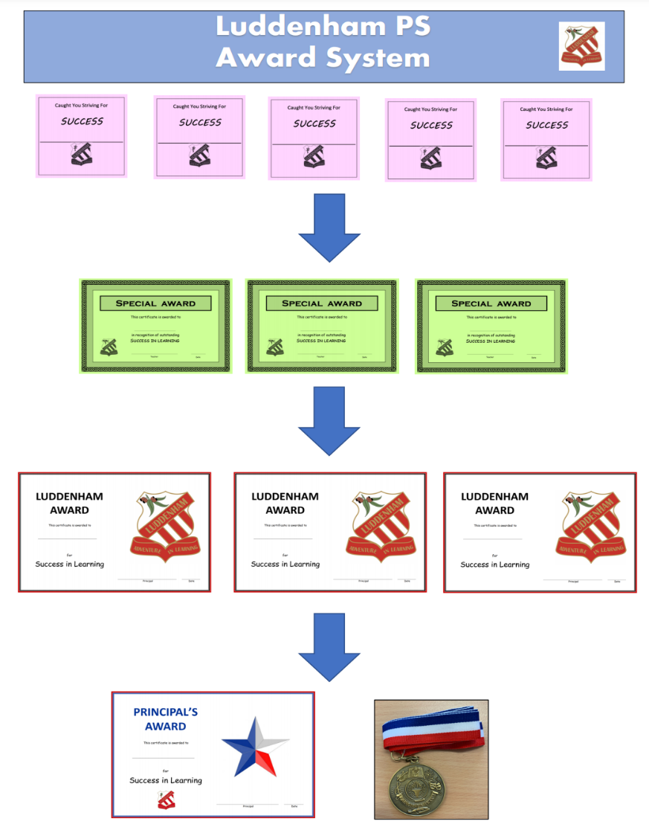
Luddenham Public School Behaviour Levels
At Luddenham Public School we believe all students have the right to learn in a safe, caring and challenging environment free from harm. We follow a level consequence system across the school when dealing with negative behaviours. Behaviours are organised into two levels – Minors (Teacher Managed) and Majors (Executive or Principal Managed) - depending on the intent with which the behaviour occurs. The system is implemented consistently across all areas of the school and follows the procedure outlined below.

Student Behaviour Flowchart
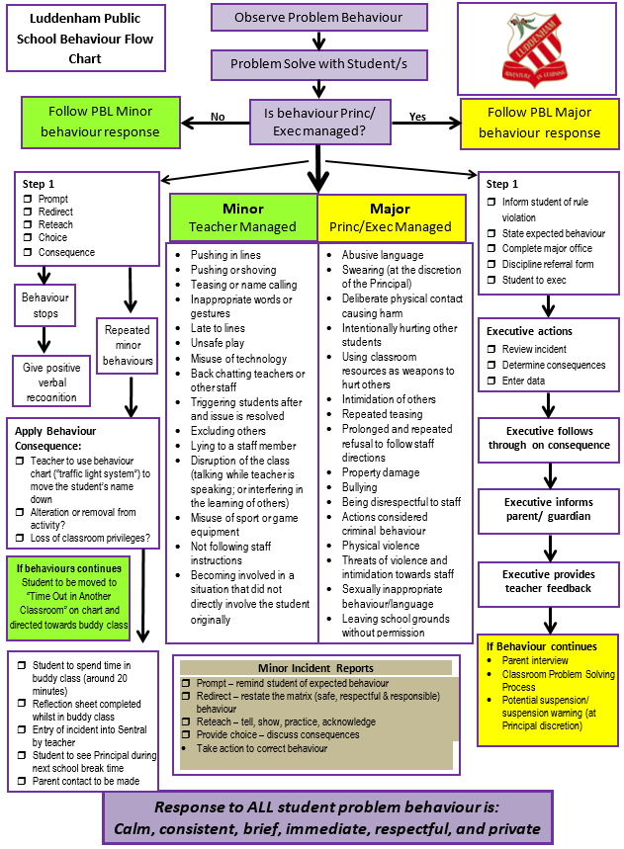
Q. How long does a student stay on behaviour chart for?
- Minimum 3 days / Maximum 5 days. If it needs to go over 5 days, a meeting with parent/s or carer/s will take place.

Q. If a child is on a behaviour chart, do they discuss their actions with the Principal?
A. Yes.

Q. Who determines what level a child should be placed after a specific behaviour has been observed?
A. The Principal in consultation with other staff members (if deemed appropriate).

Q. Who is responsible for writing the incident on SENTRAL?
A. Teacher who viewed the incident when it took place.

Q. Who decides when a student should come off a level?
A. The Principal.

Q. What takes place during discussion?
A. The Principal follows social rules programs and strategies to minimise same behaviour happening in the future.

Q. Can levels just be used for the playground and not in the classroom?
A. Yes

Q. If a child is suspended either in school or out of school at least once throughout the semester, which activities do they miss out on?
A. Off-site events, such as excursions, camps and external sporting events.

Q. What happens when a child receives 3 behaviour cards ‘Final chance’ (yellow level)?
A. They do not go to camp or excursions.

Q. Can SRC, School Leader and House badges be removed for inappropriate behaviour?
A. Yes.

Q. Where does a student go when on a ‘Final chance’ (yellow level)?
A. During all breaks they will wait in the Principal’s office and participate in social skills program.

Q. If a child is on ‘Final chance’ (yellow level), what activities do they miss out on?
A. Any school activity that is not directly related to the curriculum.

Q. If a child in Year 6 is suspended in Semester 2, what activities do they miss out on?
A. Farewell, Year 6 Graduation and any other celebration related to Year 6.

Q. If a child is ‘On watch’, what activities do they miss out on?
A. They do not miss out on anything.

